**Deliverables**

Your main deliverable for this project is a report that contains enough information for someone else to reproduce your work. The report should cover all your steps, your sources, screenshots of your execution, and a detailed description and interpretation of your results. The report should follow the structure described below. If you use a Jupyter notebook or R Markdown, please write up these sections along with your code.

* Introduction (brief overview of the problem or topic, 1-2 paragraphs)

In this project, I chose the data from [Capital Bikeshare](%20https:/www.capitalbikeshare.com/system-data). This data recorded the Capital Bikeshare trip data with trip information of every trip about date, start and end station, bike number and member type from 2010 to Oct. 2019. To store and use this data, I created a pipeline for data management, including data collecting, storing, preserving and analyzing.

* Background (why this problem or topic was selected, why it is interesting / important to address, 1-2 paragraphs)

As the 2016 Capital Bikeshare Member Survey Report stated: Capital Bikeshare make reduced the cost of travel and eased the hassle car ownership and driving. More people chose to use Capital Bikeshare instead of other transportation methods for a faster and easier access to their destinations. Many Capital Bikeshare users gave high rate about most bikeshare features and show that they will use it more if bikeshare service was expanded and other service enhancements were made.

When studying how to improve and expand bikeshare services, we are interested to answer following questions, such as how do the riders use the bikes, which stations are most popular, how to plan the quantity of bikes to meet the need for peak time riders? Upon collecting and store this kind of history data will help us make a closer look about bikeshare design, how to map the stations to mostly benefit riders, how to distribute bikes and how to promote the use of bikeshare.

* Methodology (steps taken to address the problem, including the technological setup 1-2 pgs)

1. Pipeline for data management:

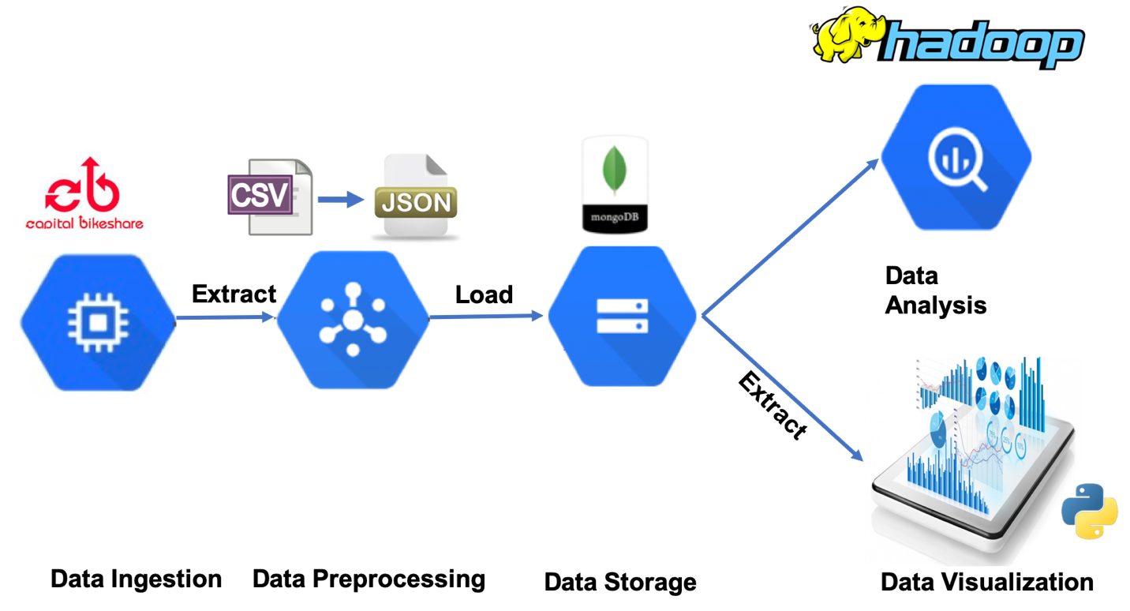

The pipeline for the project has 5 steps, including data ingestion, data processing, data storage, data visualization and data analysis. First, I created a new virtual machine on Jetsream with the image of “I535-MGMT-DATA-FA19”, modified project_utilities.py based on the same file from projectA. Write a flielists.txt to record all the zip files I want to download. Images show below is where I changed the python code to do the downloading, how it executed on the terminal.

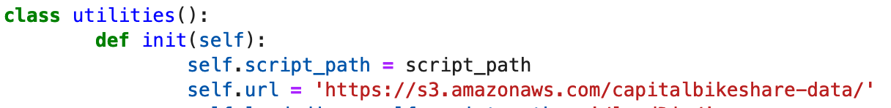

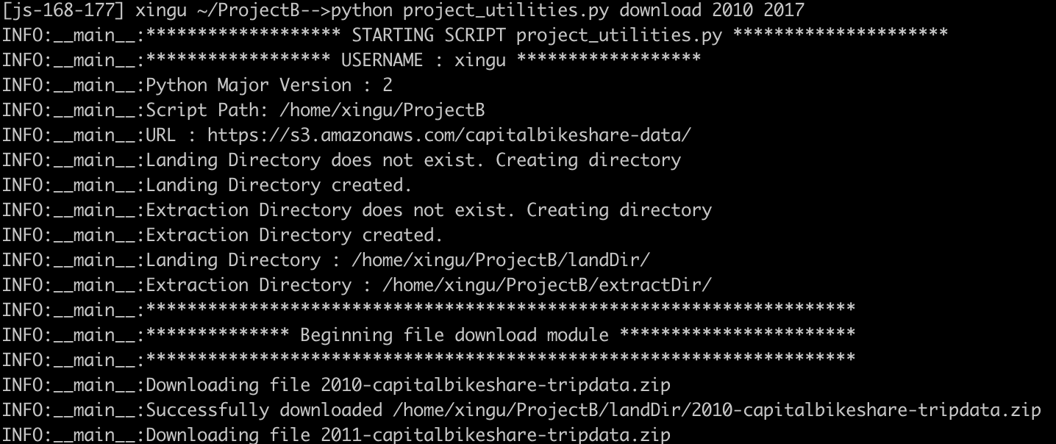

Check the file list under landDir directory, all files are downloaded.

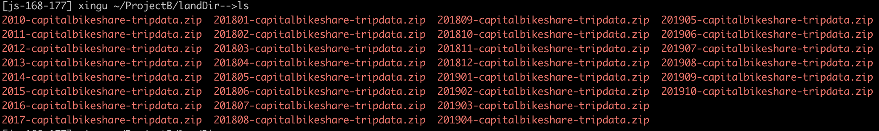

The next step is to unzip those files. I did modification of the python code shown below. And the execution results proved I have successfully unzipped all the files.



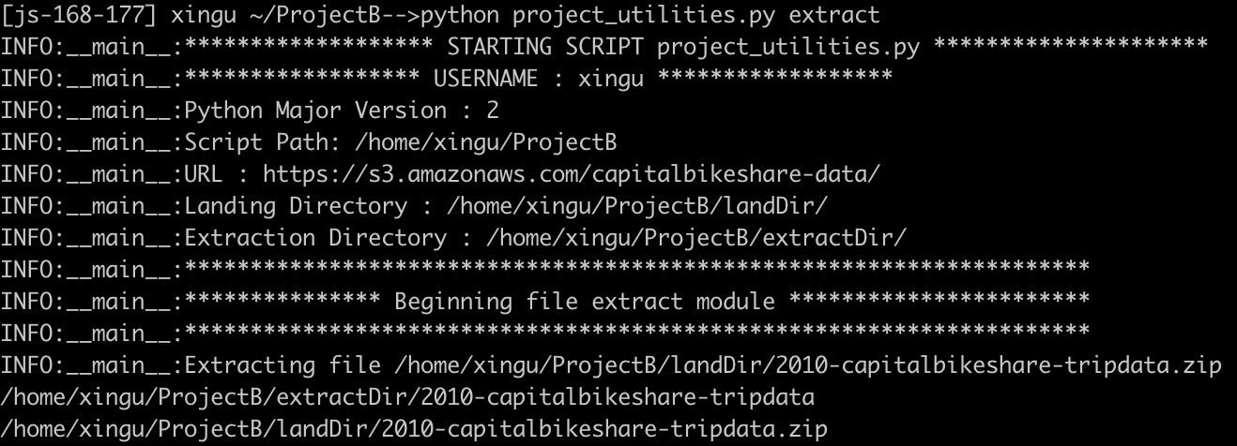

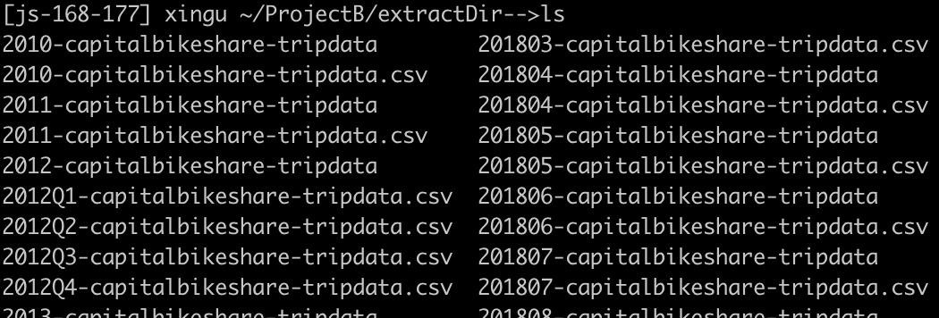

For the data storage step, I transformed the csv files into Jason files and loaded the files into mongoDB. There are 24956665 entries in the database.

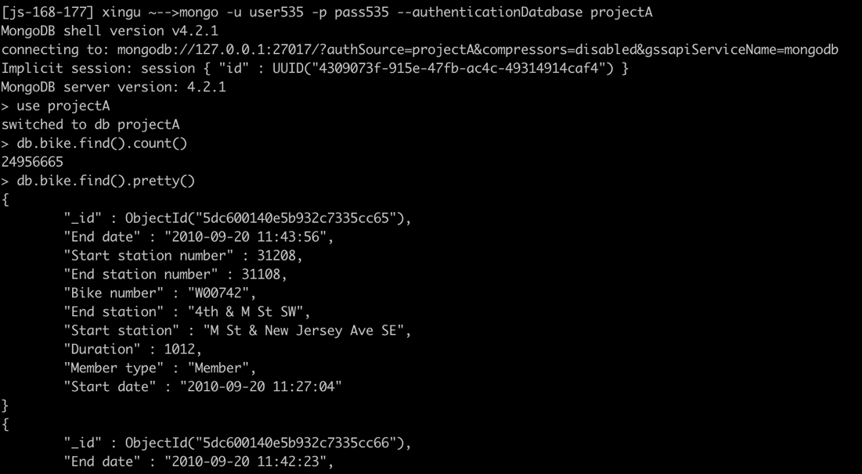

For the data analysis, I installed Hadoop by using Hadoop_install.sh and wrote mapper.py and reducer.py to count how many times the bike trip started from the same station. In mapper, it output ["Start station number"]+'\t'+str(1) pairs for every entry, and reducer will count the total number of the same “Start station number” was appeared. I did map-reduce on Hadoop distributed file system(HDFS).

Hadoop installation:



Copy csv files to Hadoop HDFS:



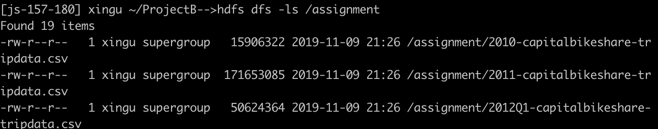

Run map-reduce:

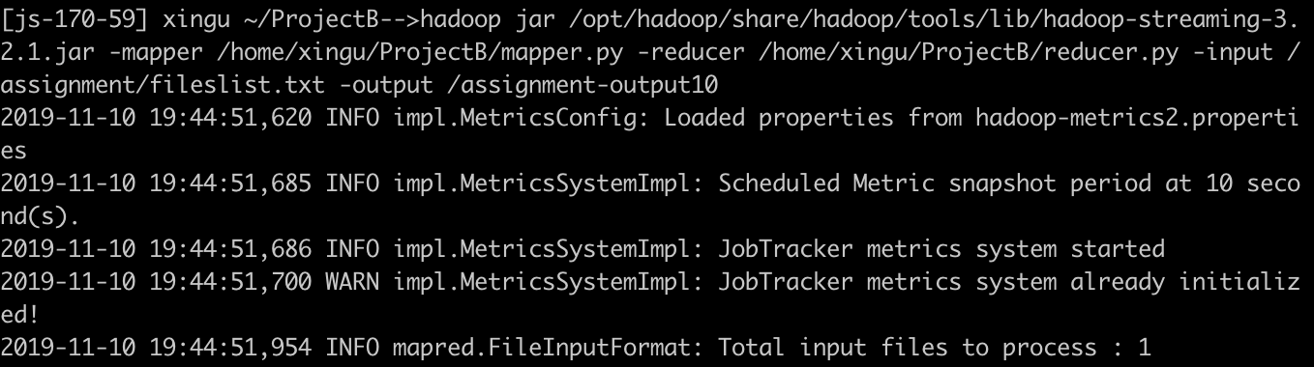

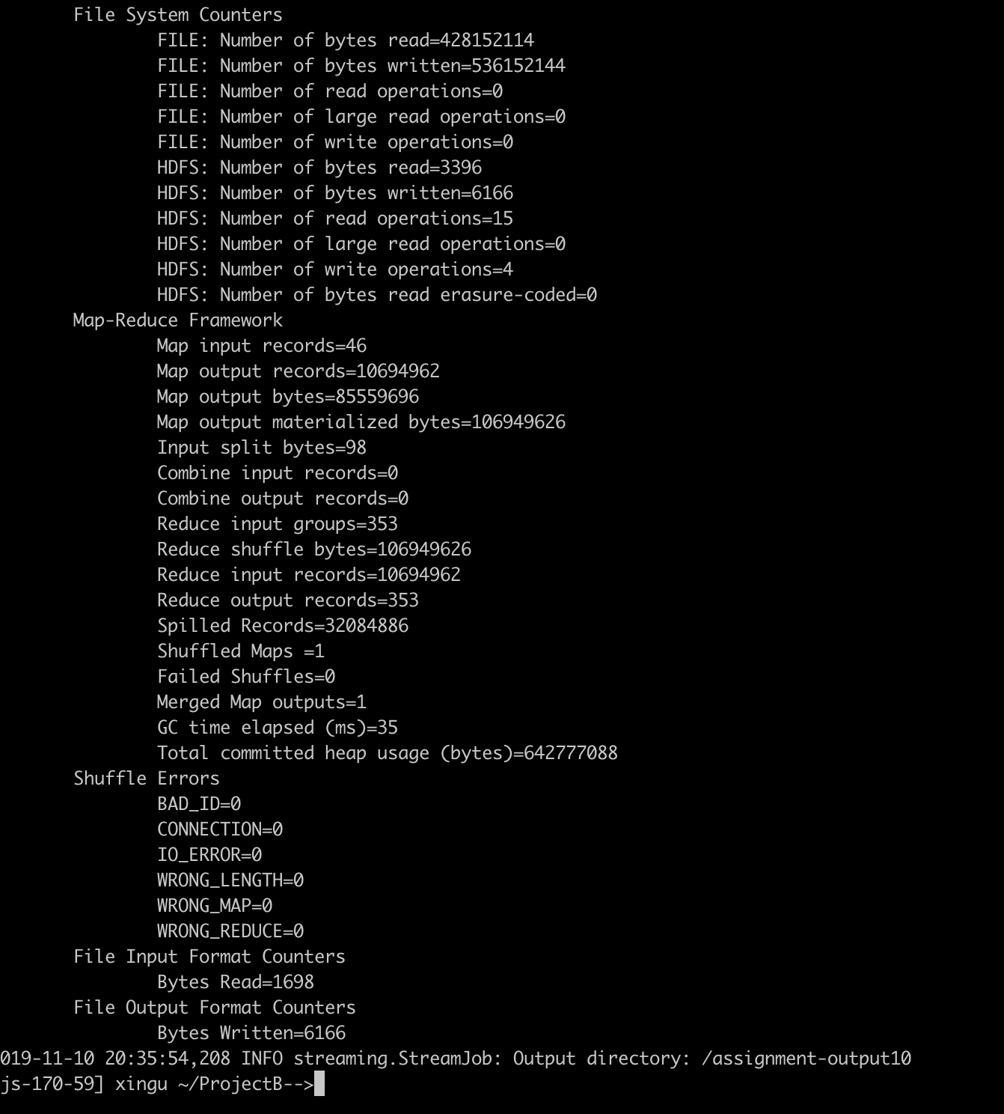

Get the map-reduce results:

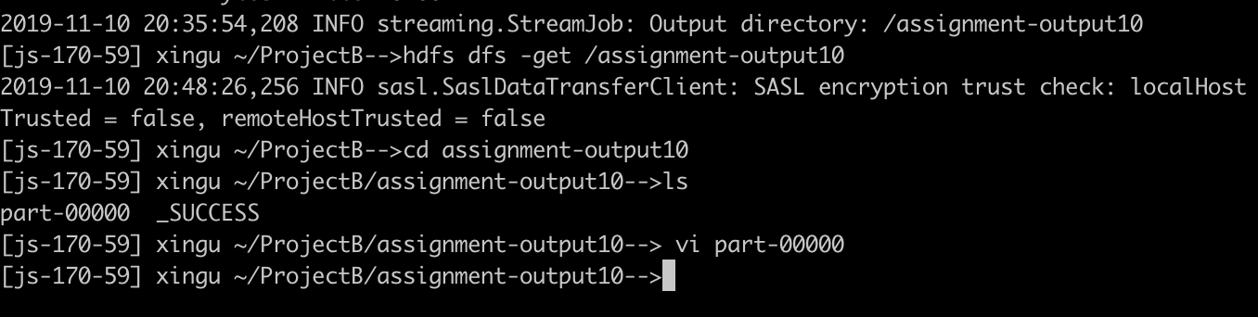

Save the results as results.csv:

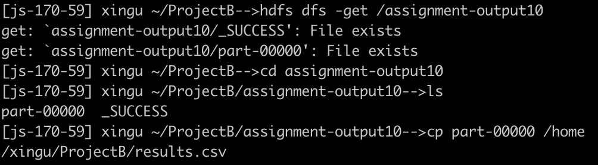

The map-reduce results:

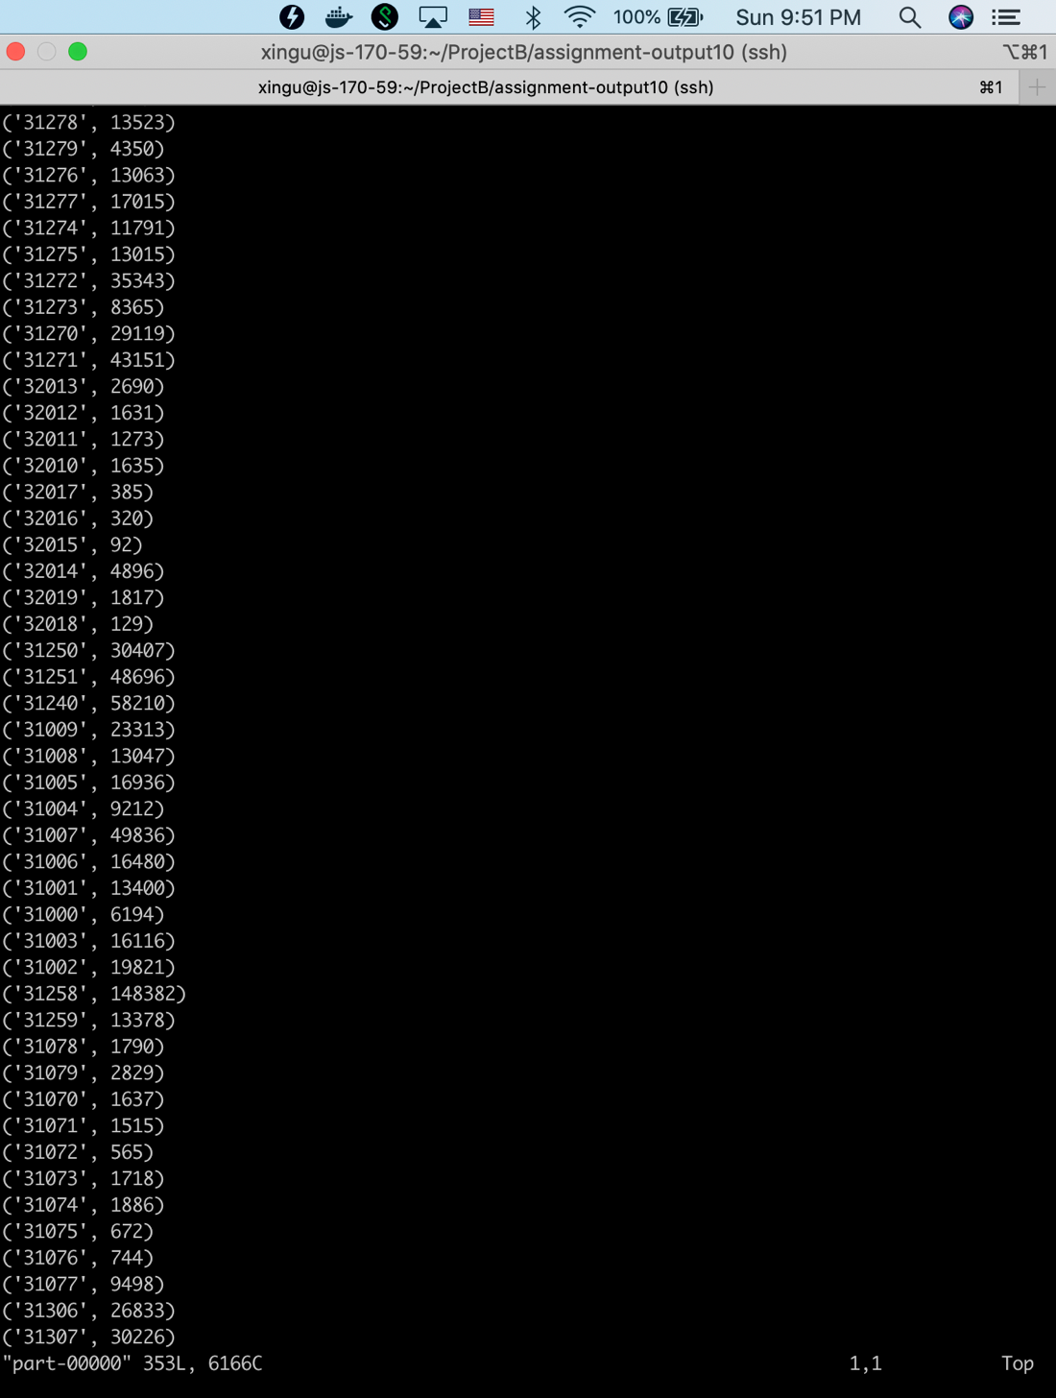



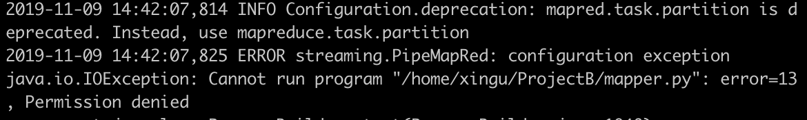

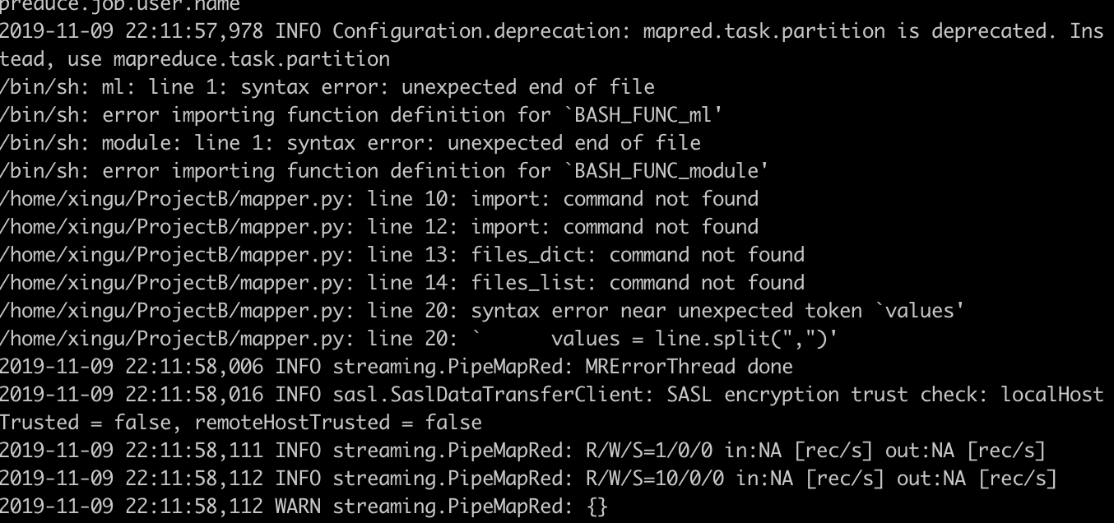

* Results (1-3 pgs)
* Discussion (an interpretation of the results + a discussion of how you employed the technologies / skills from this course + any barriers or failures you encountered, 1-2 pgs)
* Conclusion (1 paragraph)
* References

For this option you can take one of the datasets provided below and use and re-use the resources available to you in this course, including the VMs and scripts, to do the following:

- implement a simple pipeline (e.g., download - summarize - visualize)

- develop a storage model for the dataset

- run an algorithm using a parallel programming framework (using Hadoop or IU resources)

- run predictive analytics on the dataset

- propose a cleaning / quality improvement solution

- create a data management plan that describes an approach to collecting, storing, preserving and storing this dataset